
REQUEST FOR EXPRESSIONS
OF INTEREST (REOI)
2024-006 – Design, Construct and Lease Industrial Sheds in Cloncurry
Collection, use and disclosure of information
The Principal collects personal information and non-personal information in the Response so that it can properly conduct the procurement process and otherwise carry out its functions as a local government authority. The Principal is authorised to collect this information under the Local Government Act 2009 (Qld) and the Local Government Regulation 2012 (Qld). The information in the Respondent’s Response will be accessible by employees of the Principal and third-party personnel engaged to assist the Principal in conducting the procurement process or otherwise carrying out the functions of the Principal. Information in the Response may also be disclosed as required by law, including the Local Government Regulation 2012 (Qld) and the Right to Information Act 2009 (Qld).

PART 1 – BACKGROUND & FREQUENTLY ASKED QUESTIONS
What are we doing: Cloncurry Shire Council is partnering with the Queensland State Government to design and construct new industrial sheds in Cloncurry that can be commercially leased to those seeking to establish new businesses and/or expand existing businesses in Cloncurry.

The current aim is to test levels of interest in securing industrial land in Cloncurry and to confirm the type of sheds that will receive the strongest demand for leasing once constructed.
Responding to this EOI will not generate any obligations between Respondent and Council but will pave the way for future discussions and advance the infrastructure design processes.

What information do I need to provide: at this stage, we are looking for contact details, the kind of business you will either be bringing to town or looking to expand, and the shed/office design required to accommodate your business. Once we have compiled this information through this current process, we will progress discussions, designs and procurement processes further.

Why are we doing it: the overall aim of this project is to lower barriers to entry for existing businesses to expand operations or for new businesses to establish without the capital costs required to purchase land and construct facilities (shed, offices, ablutions). The project has been on the cards for the last decade, but it’s only recently that Council has been able to secure external funding to assist in the delivery of this project.

Where is it happening: the sheds will be constructed on Lot 8 of the Industrial Estate on Fred McKay Road, Cloncurry (off Andrew Daniels Drive / Heavy Vehicle Bypass). See Appendix A for mapping.

When are we doing it: Council is looking to (a) complete initial EOI stage discussions in Q4 2024; (b) to finalise designs and procurement for shed construction in Q1 2025; and (c) conclude construction of all sheds by end of Q3 2025. Some sheds will come on line in Q2 2025 and the balance in Q3 2025. Council will look to formalise tenancies through standard leasing arrangements during Q2 and Q3 2025. More information to come on this.

What kind of sheds are we looking for: we are looking to build what the market is looking for. On that basis, we are seeking your input to help customise the range of sheds that we design and construct at the Industrial Estate. This may end up being a mix of large, medium, small sheds/offices, or 2 x large sheds, or 3 x medium sheds, or whatever the optimal configuration looks like. See Appendix B for the kinds of sheds we would anticipate, while noting that Council is open to all proposals.

Reconfiguration of lot: following this EOI and subsequent design processes, Council will reconfigure Lot 8 as required. The aim here will be to secure the arrangements best suited to bringing new businesses online / allow existing businesses to expand.

Inclusions: all sheds will need to meet Council’s Planning Scheme requirements. Accordingly, all will be connected to water, sewer, power, telecoms. All lots will have fencing, landscaping etc. All other inclusions will be per final designs for sheds and associated infrastructure (e.g., office, ablutions, laydown area, no. roller doors etc.).

Purchase vs lease: the conditions of our funding approval do not allow for sale of land/structures, only for leasing.

Proposed duration of leases: while Council will be open to a range of options, Council’s preference will be for leases of 3+ years with options to renew.

Information Sessions: see over page for details of information sessions.

PART 2 – INFORMATION SESSIONS
There will be three information sessions for this Expression of Interest process for Respondents to attend, either in person or via MS TEAMS

Session 1:
Date: Friday, 15 November 2024.
Time: 3:00 – 4:00pm
Location:
- Council Admin Building: 38-42 Daintree Street, Cloncurry 4824.
- MS Teams:
Join the meeting now
Meeting ID: 429 132 218 796
Passcode: BZiGKq

Session 2:
Date: Thursday, 21 November 2024.
Time: 3:00 – 4:00pm
Location:
- Council Admin Building: 38-42 Daintree Street, Cloncurry 4824.
- MS Teams:
Join the meeting now
Meeting ID: 458 663 618 314
Passcode: wEqXJv

Session 3:
Date: Thursday, 28 November 2024.
Time: 3:00 – 4:00pm
Location:
- Council Admin Building: 38-42 Daintree Street, Cloncurry 4824.
- MS Teams
Join the meeting now
Meeting ID: 458 663 618 314
Passcode: wEqXJv

PART 3 – LODGMENT INFORMATION

Interested parties are requested to complete the following items:
- Part 4 below
- Schedule A – Cloncurry Industrial Shed (Excel format)
- Design of desired shed: photo of equivalent shed; or link or screenshot from an online Shed Building Tool; or design drawings already developed.

Please send these items to:

EMAIL: Council@cloncurry.qld.gov.au

TIME: 5:00pm

DATE: 2 December 2024

Should Respondents also wish to submit a design from an online Shed Builder Tool (e.g., Ranbuild, Action Sheds, Best Sheds, Shed Designer etc., that would be extremely helpful.

Note: Respondents who may wish to lease more than one shed should populate an Incubator Shed Schedule for each shed
PART 4 – RESPONSE SCHEDULES
Details of Respondent | Name of Respondent:  Company or other legal entity name
 | Trading name:
 | ABN:
ACN:
Leave blank if Respondent is not a company
 | Address:
Details of Respondent’s representative | Name of Representative:
 | Office Number:
 | Mobile Number:
 | Email Address:
Type of Business Activity Proposed
Link or screenshot or attachment from Online Shed Building Tool | Link to shed design: | Screenshot or Attachment of shed design:

APPENDIX A – LOT 8, CLONCURRY INDUSTRIAL ESTATE – FRED MCKAY ROAD

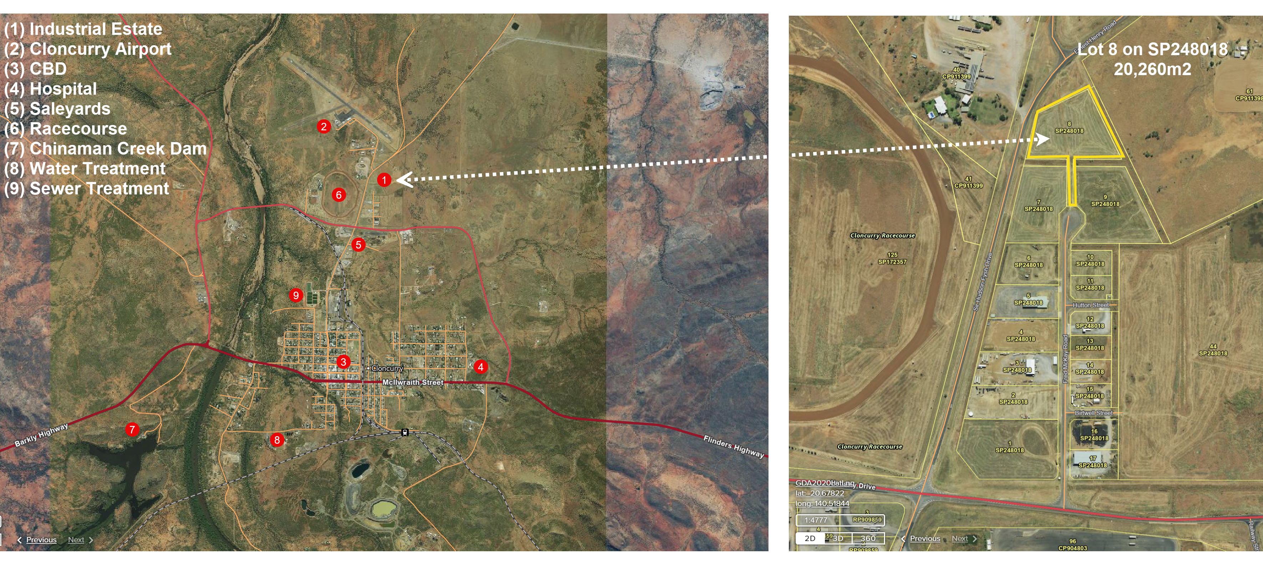

APPENDIX B – POTENTIAL TYPES OF SHEDS

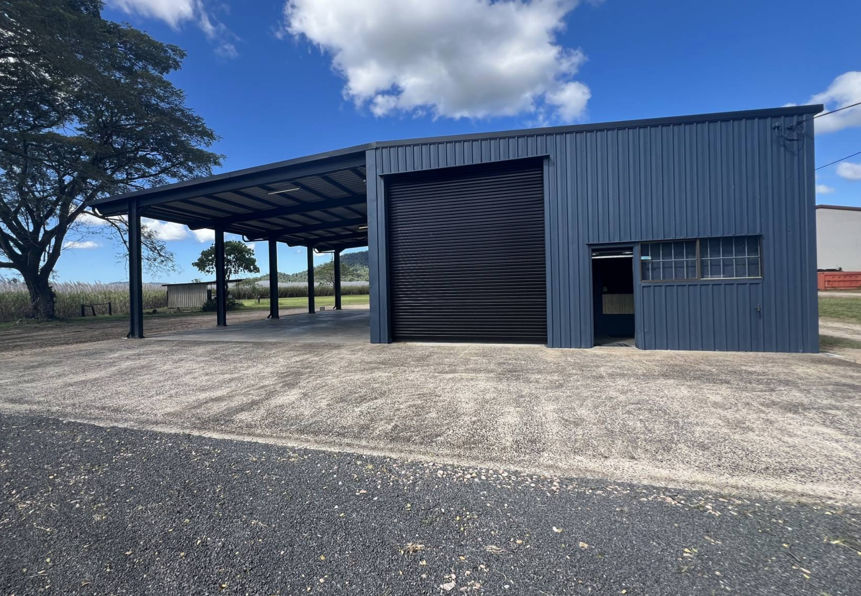

APPENDIX B – POTENTIAL TYPES OF SHEDS

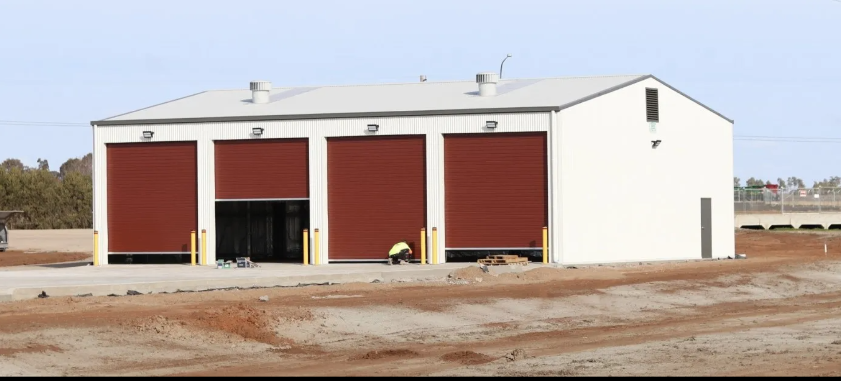
APPENDIX B – POTENTIAL TYPES OF SHEDS

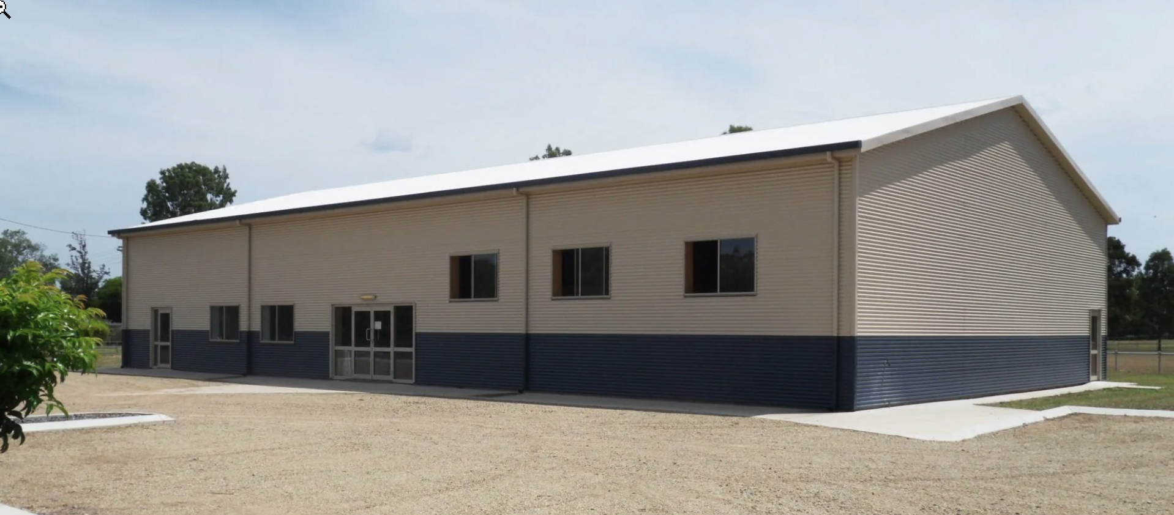

APPENDIX B – POTENTIAL TYPES OF SHEDS

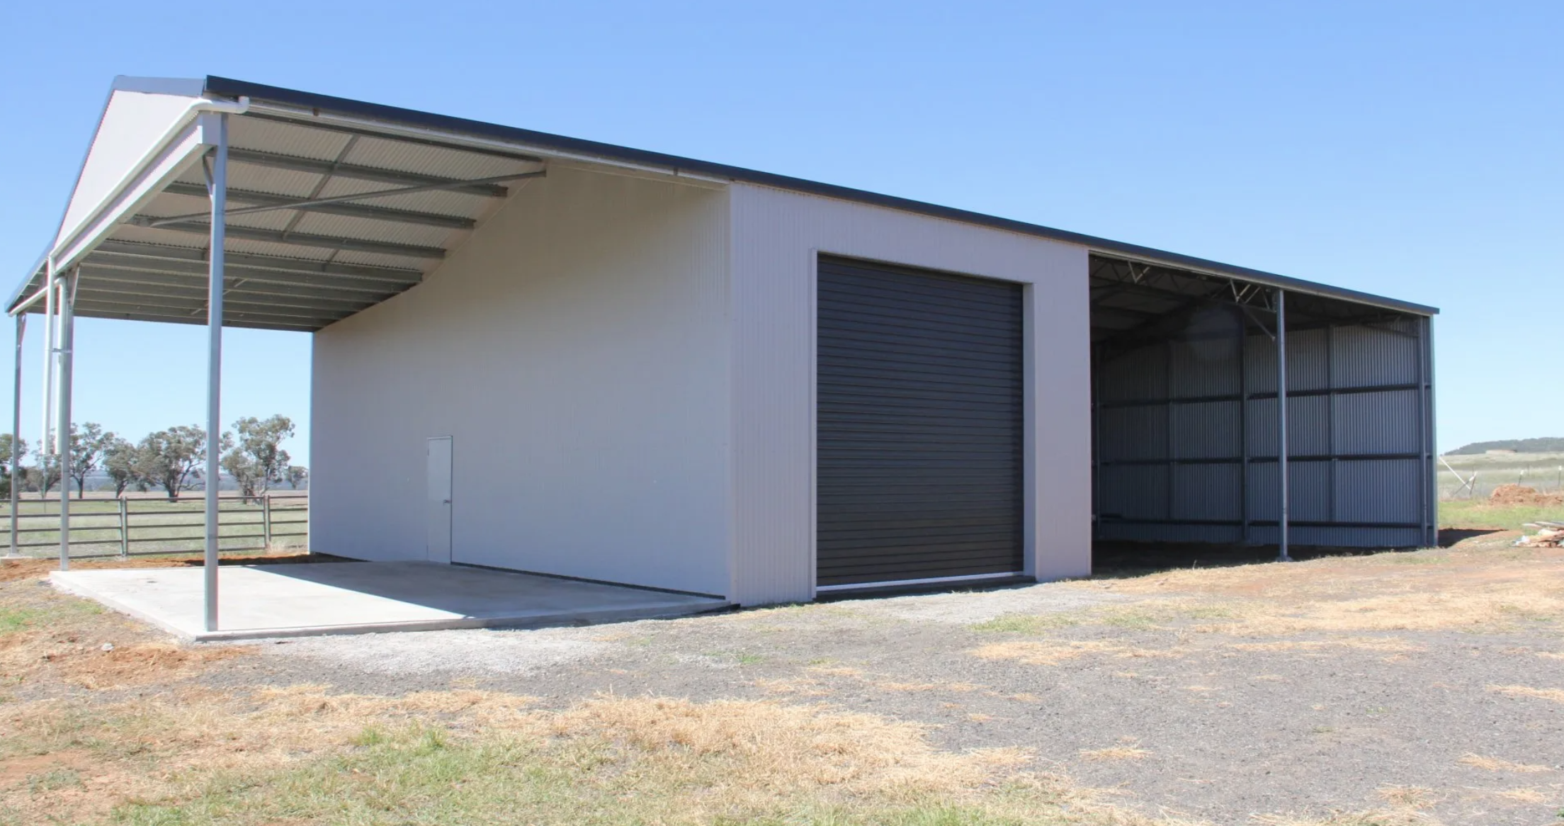

APPENDIX B – POTENTIAL TYPES OF SHEDS

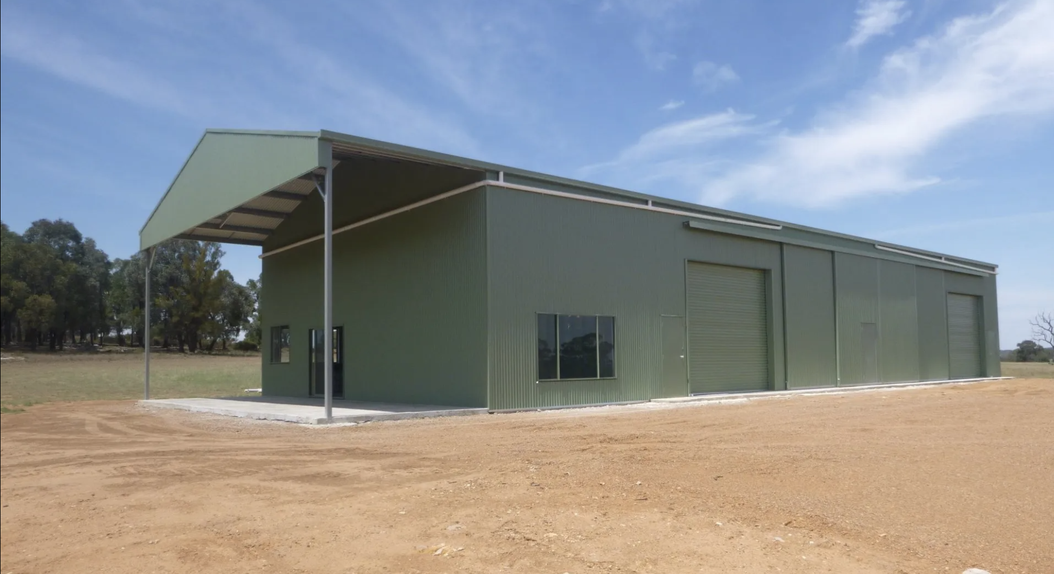
APPENDIX B – POTENTIAL TYPES OF SHEDS

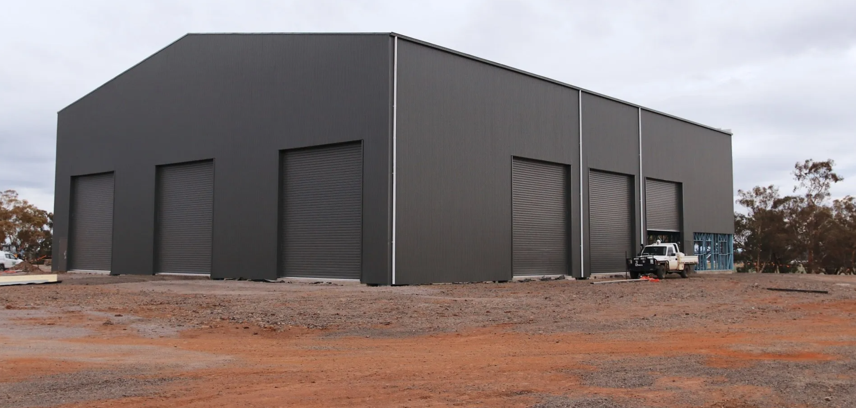
APPENDIX B – POTENTIAL TYPES OF SHEDS

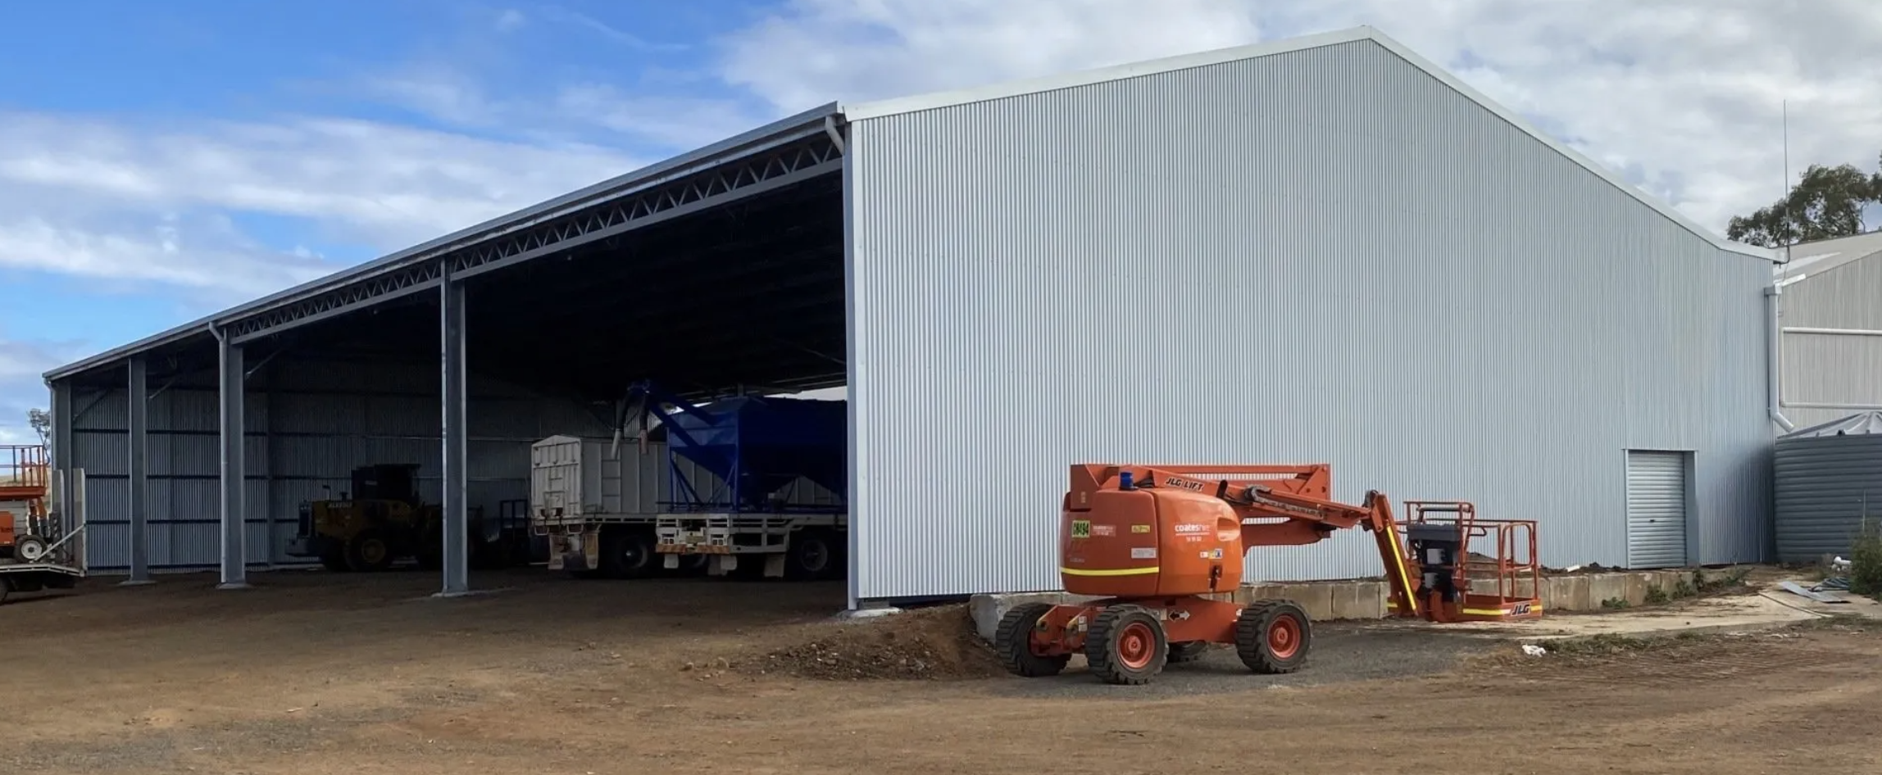

APPENDIX B – POTENTIAL TYPES OF SHEDS

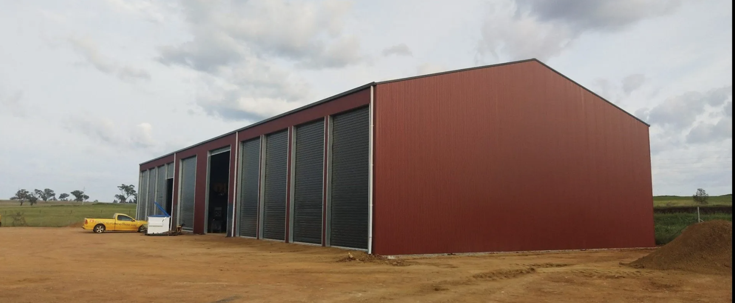

APPENDIX B – POTENTIAL TYPES OF SHEDS

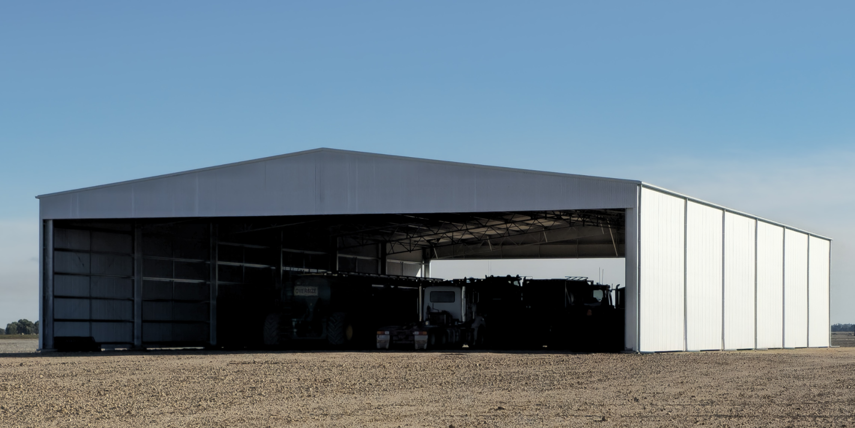

APPENDIX B – POTENTIAL TYPES OF SHEDS

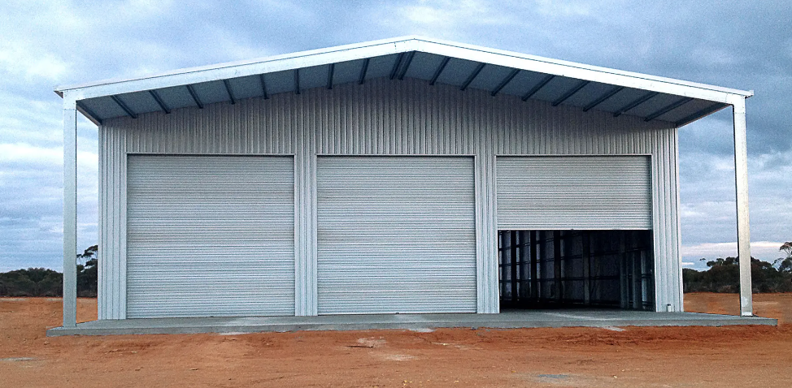

APPENDIX B – POTENTIAL TYPES OF SHEDS

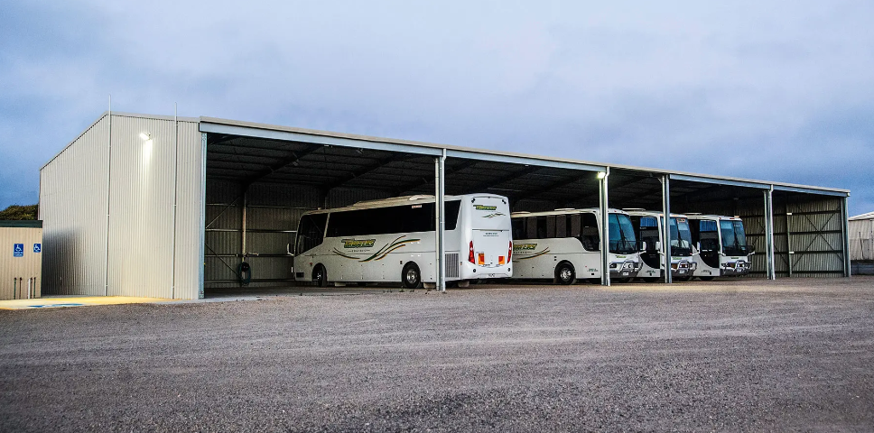

APPENDIX B – POTENTIAL TYPES OF SHEDS

